System Design Document
Grandma’s Cookbook

Grandma’s Recipe Co.
4601 Mid Rivers Mall Drive,
Cottleville, MO, 63376

3/22/2026

Table of Contents
Introduction 3
Purpose 3
System Overview 3
Design Constraints 4
4
Roles and Responsibilities 4
Project References 4
4
4
System Architecture 4
6
Database Design 6
Requirements of database 6
Supporting choice for SQL database 6
ERD Diagram 6
Table relationships 6
Hardware and Software Detailed Design 7
7
System Security and Integrity Controls 7

Introduction
This document is established to outline the detail and process behind the creation of the program “Grandma’s Cookbook”(referred to as “program” in the rest of this document). This program will allow for account creation via Google's Google auth api or via custom email and password linked directly to the programs servers, to be stored in encrypted format for security purposes. The program is to allow for the creation of recipes, the saving of said recipes locally, on the programs servers, or both, and searching other user made recipes that have been saved to the programs servers. This document will go into further detail as to the nature of these features and what must be present for each feature to be considered fully implemented.

Purpose

The purpose of this document is to outline the design principles and constraints related to the program. This is to allow for easier communication among the team responsible for the development of this program and a clear statement of intention to other interested parties. This document will clarify what is in scope for the development process, what is feasible should the development timeline allow for non-critical additions, how the program is meant to operate, and the architecture necessary for that operation. The document will outline assurances and features necessary for project completion, and thus facilitate easier tracking of the development timeline for all interested parties.

System Overview

This program is meant to provide users with an easy to operate alternative to other cooking based websites presently on the market. This program is meant to be easy to read, edit and interact with for the end user in a manner that simplifies both the shopping and cooking process. As such, it is meant to act primarily as a repository of recipes for the end user to utilize in their day to day lives, as well as a means of discovering new recipes through an easy to use search and filtering system.
This program is designed primarily as a recipe repository, and as such moves away from the style of other cooking apps and websites that prioritize a blog-adjacent format. This is intended to allow for a greater degree of readability and tracking by the end user. As such, the program is simple relative to many of its contemporaries. The full system-critical feature list is outlined below:
- Account creation via email or Google Auth
- User creation of recipes via template
- Ability to save recipes to user account and/or upload recipes to program servers
- Ability to search and browse other user created recipes that have been uploaded to program servers
- Filtering tools to allow users to browse recipes based on specified criteria
- Editing and deletion of recipes the user has created and/or saved to their account
- Serving size and measurement conversion tools

Design Constraints

The primary constraints limiting the development of this program are as follows:
- The program must be compatible with Windows architecture at minimum, but due to time constraints forks to other operating systems are likely not possible
- The program must fully incorporate all system-critical features, and thus will likely not be able to implement advanced features within the project completion deadline
- The server-side infrastructure will be inherently limited due to the minimal resources available to the project, and so system architecture must be designed with this in mind

Roles and Responsibilities

Name | Role | Email
Felix Unger | Project Manager/Security | cu235828@my.stchas.edu
Bhone Khant | Lead Designer - System Architecture | bk282807@my.stchas.edu
Lucas Vines | Lead Designer - Secondary Architecture/Flex | lv263740@my.stchas.edu
Natalie Rottmann | Lead Designer - User Interface | nr269687@my.stchas.edu
Bader Aljamal | Lead Designer - Secondary Interface/Flex | ba273893@my.stchas.edu

Project References
This program is designed using comprehensive research and a clear statement of work outlined in prior documentation. The references therein are as follows:
- Grandma’s Recipe Co. Database Research, Feb 24, 2026
- Grandma’s Recipe Co. Statement of Work, Feb 20, 2026
- Grandma’s Recipe Co. Project Proposal, Feb 20, 2026

System Architecture

Hardware:
The hardware listed is not finalized, but should theoretically be the minimum necessary for both user and server operations:
- Basic server consisting of:
  - Intel 6th gen or higher cpu (or equivalent)
  - Minimum 8GB DDR4 RAM
  - Minimum 120GB SATA SSD (240GB preferred)
  - Minimum 1TB internal HDD (2TB SSD or higher preferred for bulk storage and reliability)
  - Gigabit ethernet
- User hardware consisting of:
  - Intel 6th gen or higher cpu (or equivalent)
  - Minimum 8GB DDR4 RAM
  - Minimum 120GB internal storage
  - Minimum cpu provided onboard graphics

Software:
The program is comprised of a front and back end architecture for data creation, insertion and querying by the end user. This architecture is designed to take data input from the end user to log them into an account associated with a given Google account or generic email and password, and allow the creation and storing of recipe data associated with that account. The components necessary for this are as follows:
- User Data Entry: This component provides a user interface to create recipe modules that can be saved with association to a given user account. The data associated with recipe modules is as follows:
  - Recipe name
  - Recipe description
  - Recipe picture
  - Cooking instructions
  - Ingredient list
  - Preparation and Cooking time
  - Serving sizes
- User Account Management: This component provides the user with a means to create and alter an account via Google Auth or generic email and password. The user can create and alter a username via this component, as well as change the email and password associated with the account.
- Saved Recipe Management: This component allows the user to search through and alter a list of recipes created by or otherwise saved to an associated account.

Database Design

Requirements of database
The application will require certain traits from the database system used to serve and store app data. Examining the entities used in the app, we see the requirement for relationships between users and their recipes or shopping lists. Furthermore, the search and filter feature of the app will also require a database that is able to store structured data to achieve consistency and allow specific queries. Traits such as cascading deletion and built-in constraints within the database also complement the CRUD operations of the user and allow separation of concerns, allowing ease of troubleshooting and development.

Supporting choice for SQL database
Given the requirements mentioned above, a relational database management system (RDBMS) is chosen for its support for complex queries, foreign key constraints, cascading operations and its ACID (Atomicity, Consistency, Isolation, Durability) trait allows reliable data processing and prevents anomalies such as orphan shopping lists. Additionally, the selected database must support temporal data storage to record account creation. Due to these reasons, the app will be using MySQL to fulfil its data handling needs.

ERD Diagram
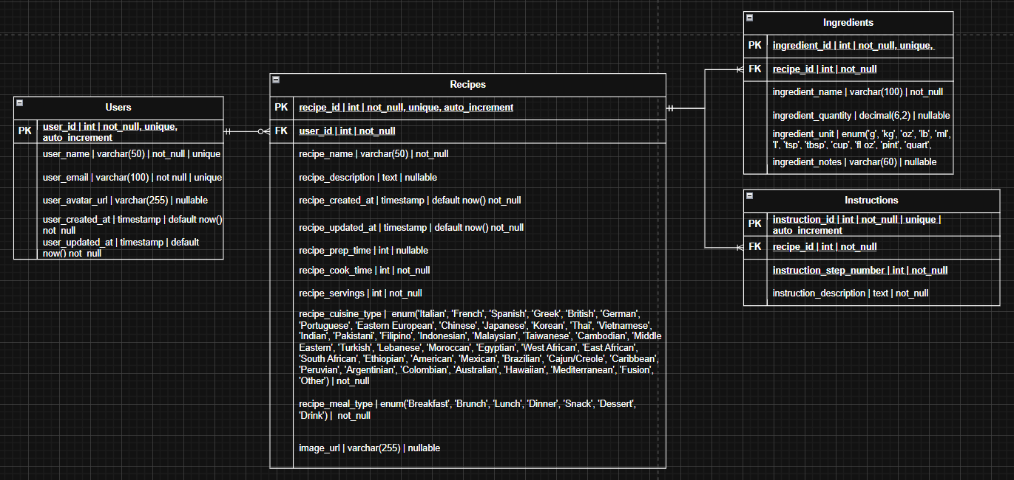

Table relationships
Users → Recipes (One-to-Many) A user can author many recipes, but each recipe belongs to exactly one user. This relationship is established through the user_id foreign key in the Recipes table referencing the primary key of the Users table. Cascading deletion is applied, meaning all recipes authored by a user are automatically removed if that user's account is deleted.
Recipes → Ingredients (One-to-Many) A recipe can contain many ingredients, but each ingredient entry belongs to exactly one recipe. This relationship is established through the recipe_id foreign key in the Ingredients table referencing the primary key of the Recipes table. Cascading deletion ensures all ingredients associated with a recipe are removed when that recipe is deleted.
Recipes → Instructions (One-to-Many) A recipe can contain many instruction steps, but each instruction belongs to exactly one recipe. This relationship is established through the recipe_id foreign key in the Instructions table referencing the primary key of the Recipes table. Steps are ordered using the instruction_step_number field to guarantee correct sequencing when retrieved. Cascading deletion ensures all instructions associated with a recipe are removed when that recipe is deleted.

Hardware and Software Detailed Design

Hardware:
No further hardware design is required beyond that specified within the System Architecture. Existing hardware specifications can be found above in the System Architecture hardware specifications section of this document.

Software:
This program is coded and designed by the team at Grandma’s Recipe Co. and designed to run specifically on Windows operating system architecture. This program is built upon Quasar as its primary front end architecture with HTML implementation for web connectivity and a MySQL server-side framework for data storage and query.

System Security and Integrity Controls
This program is to implement account data encryption via the standard RSA algorithm. This data encryption algorithm is an industry standard for secure user-server communication and will allow for safe password management and storage. Account details will thus never be stored as plain text server side and will only be user accessible after verification through proper key decryption.
A system for server-side data backups may be explored but is potentially out of scope for the timeline of this project, and is thus not a guarantee.
Sponsor Acceptance

Approved by the Project Sponsor:

Date:
<Faculty Sponsor>
<Faculty Sponsor Title>

This free System Design Document Template is brought to you by www.ProjectManagementDocs.com

